Palm/Passion Sunday
April 5, 2020
In the year of pandemic, we worship from our homes

Please, join from where you are as you feel comfortable.
Greeting and announcements

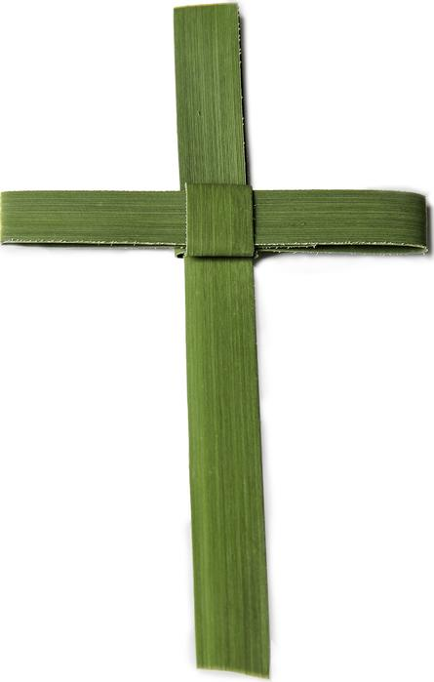
Call to Worship (based on Psalm 118:19-29)
Pastor: This is the day the Lord has made;
People: Let us rejoice and be glad in it.
Pastor: This is the gate of the Lord;
People: the just shall enter through it.
Pastor: This is the Lord’s doing;
People: it is marvelous in our eyes.
Pastor: Save us, we ask you, O Lord.
People: Blessed is the one who comes in the name of the Lord.
Pastor: The Lord is God, and God has given us light.
People: Praise God on the way to the altar with branches.
Pastor: O give thanks to the Lord, for God is good.
People: God’s steadfast love endures forever.

Opening Prayer (in unison)
God our strength,
you waken us morning by morning with your gracious word:
Help us to stand together against the enemies of life
and offer your mercy to the weary,
in the name of Jesus who did not hide his face
but stood firm before death to save the world. Amen.

Meditation: Palm Sunday and the week ahead.

Communion

Prayer of Confession: (This is not often included in DOC communion services, I think it’s important for this Sunday; please join as you are comfortable doing so.)

Save us, O God, for we are surrounded by danger
and we live in death’s shadow.
Forgive us when we fail to stand with the suffering,
when fear causes us to close our eyes to wrongdoing,
when weakness makes us turn back from following you.
Lift us up to the hope and healing of the cross;
make us bearers of the love of Jesus, poured out for the world.
Amen.

Words of Assurance: Pastor

Sharing of Bread and Cup
Benediction

